FORM 2

THE PATENTS ACT, 1970 (39 of 1970)
&

THE PATENTS RULES, 2003 COMPLETE SPECIFICATION
- TITLE OF THE INVENTION

EmoMelody Mapper- Emotion Based Music Player
- APPLICANT(S)

Name in Full | Nationality | Country of  Residence | Address of the Applicant
Shruti Jain | Indian | India | Department of Computer Science, KIET Group of Institutions, Delhi-NCR, Ghaziabad, Uttar Pradesh, India 201206.
Unnati Tandon | Indian | India | Department of Computer Science, KIET Group of Institutions, Delhi-NCR, Ghaziabad, Uttar Pradesh, India 201206.
Shubhangi Rai | Indian | India | Department of Computer Science, KIET Group of Institutions, Delhi-NCR, Ghaziabad, Uttar Pradesh, India 201206.
Aarti Sharma | Indian | India | Department of Computer Science, KIET Group of Institutions, Delhi-NCR, Ghaziabad, Uttar Pradesh, India 201206.

- PREAMBLE TO DESCRIPTION

COMPLETE SPECIFICATION -
The following specification particularly describes the invention and the manner in which it is to be performed.

Title:

EmoMelody Mapper- Emotion Based Music Player

Field of the Invention

[0001] The embodiment of current innovation pertains to the domain of computer science and the field of computer vision.

Background

[0002] The embodiment of this innovation involves the development of an Emotion-Based Music Player that dynamically selects and plays music based on the user's emotional state. Traditional music players lack the ability to adapt to the user's emotional context, resulting in a less personalized music listening experience.

[0003] The background description provided includes all relevant information to enhance the understanding of the invention. This does not imply that any information or statements contained herein are to be accepted as prior art or in connection with any currently claimed invention.

[0004] The proposed EmoMelody Mapper aims to overcome the limitations of traditional music players by integrating facial emotion recognition technology. This system leverages computer vision techniques, machine learning models, and real-time emotion analysis to provide a personalized and emotionally responsive music listening experience.
[0005] The development of EmoMelody Mapper is motivated by the need for a music player that can adapt to the user's emotional state, creating a more engaging and satisfying music experience. By using facial emotion recognition, the system can analyze the user's emotional expressions and select music that aligns with their current mood.
[0006] With the evolution of digital music platforms, users now have access to vast libraries of songs. However, the sheer volume of choices can lead to decision fatigue, and traditional music recommendation algorithms often rely on historical preferences rather than the user's current emotional state. EmoMelody Mapper addresses this gap by introducing a paradigm shift in music consumption, acknowledging that emotions play a crucial role in the enjoyment of music. As users engage with diverse genres and moods, the music player learns and adapts, ensuring a dynamic and emotionally resonant playlist. This aligns with the evolving landscape of personalized digital experiences, where technology goes beyond utility to create meaningful and emotionally satisfying interactions with users. EmoMelody Mapper represents a step forward in the fusion of technology and emotion, enhancing the emotional connection users have with their music.
[0007] Central to the functionality of EmoMelody Mapper is the implementation of Convolutional Neural Networks (CNN) for facial emotion recognition. CNNs are deep learning models that excel at image analysis tasks. In the context of EmoMelody Mapper, CNNs play a pivotal role in accurately identifying and classifying facial expressions indicative of various emotions. By training the CNN on a diverse dataset of facial expressions, the system becomes adept at recognizing subtle nuances in emotions, ensuring a precise and responsive music selection based on the user's evolving emotional state. The integration of CNNs enhances the robustness and accuracy of EmoMelody Mapper, contributing to its effectiveness in delivering a personalized and emotionally rich music experience.
[0008] All publications herein are incorporated by reference to the same extent as if each individual publication or patent application were specifically and individually indicated to be incorporated by reference. Where a definition or use of a term in an incorporated reference is inconsistent or contrary to the definition of that term provided herein, the definition of that term provided herein applies and the definition of that term in the reference does not apply.
[0009] In some embodiments, the numbers expressing quantities of ingredients, properties such as concentration, reaction conditions, and so forth, used to describe and claim certain embodiments of the invention are to be understood as being modified in some instances by the term “about.” Accordingly, in some embodiments, the numerical parameters set forth in the written description and attached claims are approximations that can vary depending upon the desired properties sought to be obtained by a particular embodiment. In some embodiments, the numerical parameters should be construed in light of the number of reported significant digits and by applying ordinary rounding techniques. Notwithstanding that the numerical ranges and parameters setting forth the broad scope of some embodiments of the invention are approximations, the numerical values set forth in the specific examples are reported as precisely as practicable. The numerical values presented in some embodiments of the invention may contain certain errors necessarily resulting from the standard deviation found in their respective testing measurements.

[0010] As used in the description herein and throughout the claims that follow, the meaning of “a,” “an,” and “the” includes plural reference unless the context clearly dictates otherwise. Also, as used in the description herein, the meaning of “in” includes “in” and “on” unless the context clearly dictates otherwise.

[0011] The recitation of ranges of values herein is merely intended to serve as a shorthand method of referring individually to each separate value falling within the range. Unless otherwise indicated herein, each individual value is incorporated into the specification as if it were individually recited herein. All methods described herein can be performed in any suitable order unless otherwise indicated herein or otherwise clearly contradicted by context. The use of any and all examples, or exemplary language (e.g. “such as”) provided with respect to certain embodiments herein is intended merely to better illuminate the invention and does not pose a limitation on the scope of the invention otherwise claimed. No language in the specification should be construed as indicating any non- claimed element essential to the practice of the invention.

[0012] Groupings of alternative elements or embodiments of the invention disclosed herein are not to be construed as limitations. Each group member can be referred to and claimed individually or in any combination with other members of the group or other elements found herein. One or more members of a group can be included in, or deleted from, a group for reasons of convenience and/or patentability. When any such inclusion or deletion occurs, the specification is herein deemed to contain the group as modified thus fulfilling the written description of all Markush groups used in the appended claims.

Objectives of the Invention

[0013] The following are the objectives of the present disclosure:
- Creating an Emotion-Based Music Player that adapts to the user's emotional state.
- Leveraging facial emotion recognition technology for real-time emotion analysis using Convolutional Neural Network (CNN) Algorithm.
- Enhancing the user experience by providing a personalized and dynamically changing music playlist.

Drawings

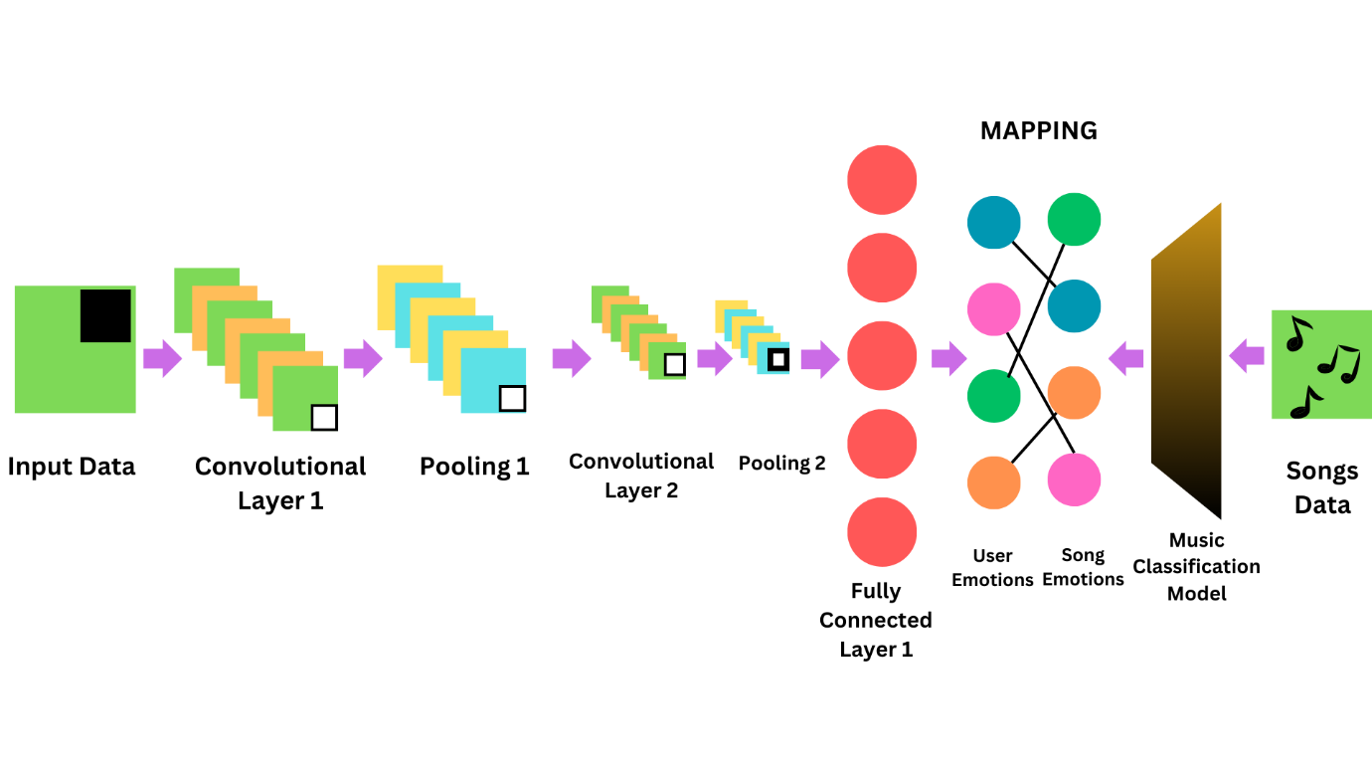

Figure 1

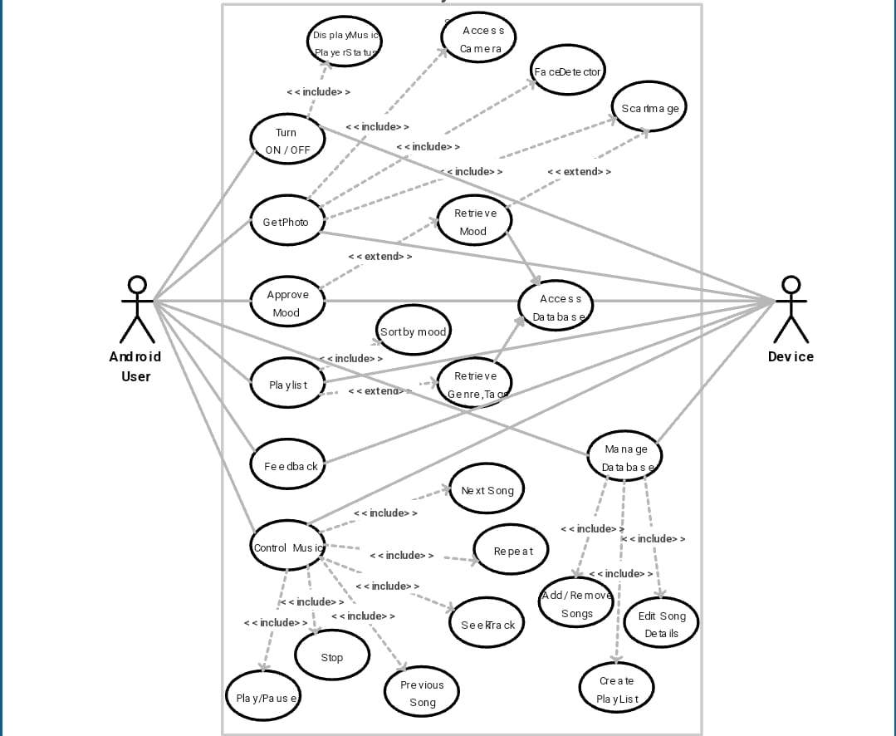

Figure 2

Brief Description of the Drawing

[0014] Figure 1 represents the model in the present invention with its prototype.

[0015] Figure 2 represents the use case diagram of the embodied invention.

Detailed Description:

[0016] In Figure 1, the input parameters are shown, which are processed by the EmoMelody Mapper system.
[0017] EmoMelody Mapper utilizes facial emotion recognition through computer vision techniques. It integrates a webcam for real-time capture of the user's facial expressions. A Haar Cascade Classifier is employed for face detection, and a pre-trained deep learning model using Convolutional Neural Network (CNN) analyzes the facial expressions for emotion classification.
[0018] The Music Selection Algorithm involves creating a user emotion profile based on detected emotions during the music listening session. Song weights are calculated, prioritizing songs that align with the user's emotional state. Dynamic playlist generation ensures a seamless and emotionally resonant music experience.
[0019] EmoMelody Mapper, with its revolutionary Emotion-Based Music Player, caters to diverse users. Individuals enjoy a personalized musical journey, streaming platforms boost engagement with adaptive playlists, and artists connect emotionally with audiences. The invention extends to therapeutic applications and enhances live events, reshaping music experiences across industries.
[0020] In an aspect, any or a combination of machine learning mechanisms such as decision tree learning, Bayesian network, deep learning, random forest, supervised vector machines, reinforcement learning, prediction models, Statistical Algorithms, Classification, Logistic Regression, Support Vector Machines, Linear Discriminant Analysis, K- Nearest Neighbours, Decision Trees, Random Forests, Regression, Linear Regression, Support Vector Regression, Logistic Regression, Ridge Regression, Partial Least-Squares Regression, Non-Linear Regression, Clustering, Hierarchical Clustering – Agglomerative, Hierarchical Clustering
– Divisive, K-Means Clustering, K-Nearest Neighbours Clustering, EM (Expectation Maximization) Clustering, Principal Components Analysis Clustering (PCA), Dimensionality Reduction, Non-Negative Matrix Factorization (NMF), Kernel PCA, Linear Discriminant Analysis (LDA), Generalized Discriminant Analysis (kernel trick again), Ensemble Algorithms, Deep Learning, Reinforcement Learning, AutoML (Bonus) and the like can be employed to learn sensor/hardware components.
[0021] The term “non-transitory storage device” or “storage” or “memory,” as used herein relates to a random access memory, read only memory and variants thereof, in which a computer can store data or software for any duration.
[0022] It should be apparent to those skilled in the art that many more modifications besides those already described are possible without departing from the inventive concepts herein. The inventive subject matter, therefore, is not to be restricted except in the spirit of the appended claims. Moreover, in interpreting both the specification and the claims, all terms should be interpreted in the broadest possible manner consistent with the context. In particular, the terms “comprises” and “comprising” should be interpreted as referring to elements, components, or steps in a non-
exclusive manner, indicating that the referenced elements, components, or
steps may be present, or utilized, or combined with other elements, components, or steps that are not expressly referenced. Where the specification claims refer to at least one of something selected from the group consisting of A, B, C …. and N, the text should be interpreted as requiring only one element from the group, not A plus N, or B plus N, etc.

Advantages:

- Personalized music experience based on real-time emotions.
- Dynamic playlist generation for a more engaging user experience.
- Integration of computer vision and machine learning for accurate emotion analysis.

Claims

We Claim:

The following are the claims of the invention:
- Analyzing and identifying patterns in human emotion detection while listening to music.
- A system for emotion-based music selection comprising a webcam, Haar Cascade Classifier, and a deep learning model for real-time emotion analysis.
- Utilizing system webcams to gather data on the user’s music listening patterns and suggestion of songs accordingly.
- Employing machine learning algorithms to analyze the collected data and identify patterns consistent with shifting emotions, such as changing mood after listening to music.
- A method for dynamically generating playlists based on user emotions using song weight calculation using machine learning model NLP on music to categorize the music.

Abstract

The embodiment of the invention relates to a novel Emotion-Based Music Player system and method that leverages facial emotion recognition to dynamically select and play music based on the user's emotional state. The system utilizes computer vision techniques, machine learning models, and real-time emotion analysis to create a personalized and emotionally responsive music listening experience. Emotion Based Music Player system and method presented here offer a unique and innovative approach to music selection, enhancing user engagement and satisfaction. The integration of facial emotion recognition technology with a sophisticated music selection algorithm represents a significant advancement in the field of personalized music experiences.

Date:26-12-2023

Aarti Sharma et al.

